601 Devereux st
raleigh, nc 27605
phone: 919-856-8200
fax: 919-856-8234

Dear Parent/Guardian:
The Wake County Public School System’s Healthful Living Department is providing a new online program called Welnet®. This tool will help teachers and students partner to develop an individualized Physical Education program that focuses on promoting fitness and healthy behaviors.

Welnet® is a web-based system used to assess fitness and health. This system enables educators to measure components of physical fitness, check for understanding of fitness and health concepts, gather information on health-related behaviors, and retain student historical data in a safe and secure environment. The use of Welnet® will help encourage students to form habits leading to active and healthy lives.

The Welnet® program allows teachers to print individual and group reports and analyze report results. Your child will have the ability to access his/her own personal Welnet® Fitness Profile, fitness scores and fitness history from any internet-enabled device at school or off campus. As a parent/guardian, you will also be able to follow your child’s fitness scores and progress through printed system-generated reports, discussions with me, and direct internet access to your child’s data.

You and your child will find Welnet® simple to access and use. Our district is committed to maintaining the highest level of security and privacy controls on our Welnet® system and will treat these data with the same level of confidentiality as we do all other student data. A unique login and password will be provided to your child granting access to their personal fitness information.

I will continue to send additional information throughout the year. Please let me know if you have any questions or need additional information.

Sincerely,
Dominic Hardy
Physical Education Specialist
Partnership Elementary
dhardy@wcpss.net

How to Access the Welnet Website

Step 1 – Visit the Focused Fitness Website
Step 2 – Enter the login information provided by your Healthful Living teacher in the Welnet area on the bottom-left of the page | 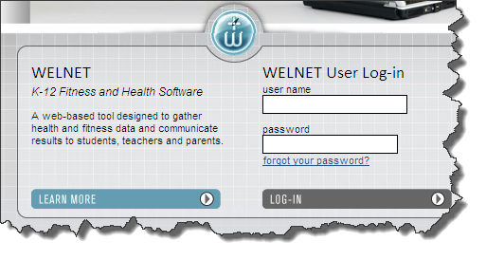
Step 3 – Click the Fitness tab on the left side of the page | 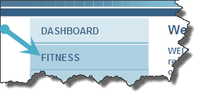
Step 4  Look at historical data to see how you’ve done on previous fitness assessments (A & B)  and  Set personal improvement goals for the next time you record your scores (C) | 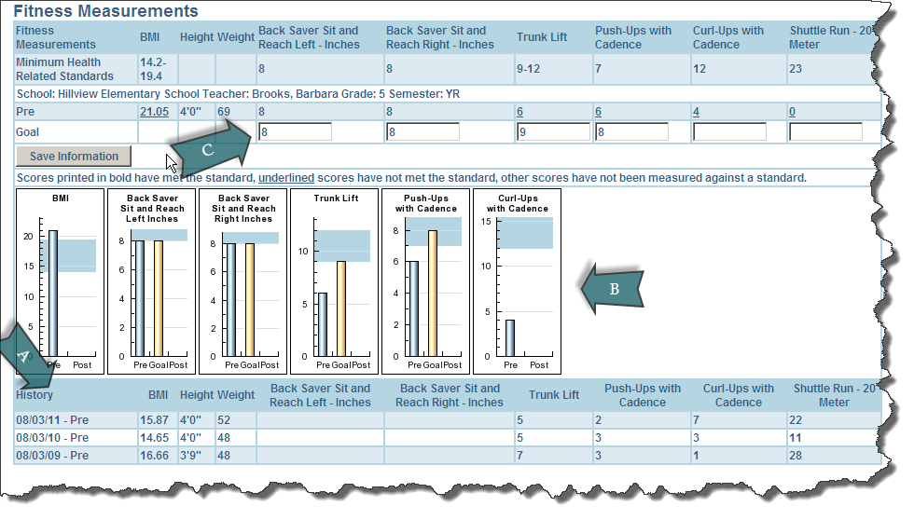

Your Username ________________________

Your Password _________________________

